### [**Chapter 8 Hands On**](https://ilearn-northern.wvnet.edu/webapps/assignment/uploadAssignment?content_id=_539433_1&course_id=_13446_1&group_id=&mode=view)

As usual, this assignment will require that you perform steps on thompson, take Screenshots of your actions and describe those screenshots.

**IMPORTANT: Please do NOT take whole desktop screenshots. This makes reading your Putty screen almost impossible. Either screenshot only the window, or use paint to crop the image. It also helps if you do not have Putty maximized when you take the screenshot.**

1) Using Putty, log in to thompson using your user account and password

2) Use wget to download the file located at <http://cit.wvncc.edu/~jdoolin/DCVMStools.tar.gz>

3) Use the 'file' command on the file you just downloaded to get its information.

4) Enter the following commands:

* tar -tzvf DCVMStools.tar.gz
* ls
* tar -xzvf DCVMStools.tar.gz
* ls
* **Take a screenshot after the second 'tar' command. Describe what these two commands did after the screenshot.**

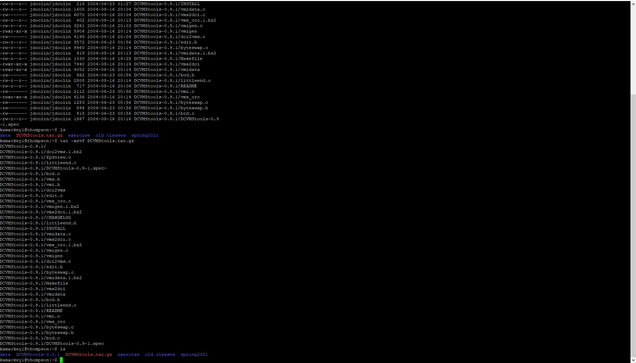

**Tar saves files as an achieve and allows you restore files from the archive.**

**The first tar commands lists the contents of the archive, filters the archive through gzip and lists files processed and then uses archive file.**

**The second tar extracts the .tar.gz file, similar to a zip file, it creates a new directory that holds the application source.**

5) Delete the directory that was just created as well as the tarball (the .tar.gz file) that you downloaded.

6) Enter the following commands:

* wget <http://cit.wvncc.edu/~jdoolin/DCVMStools.tar.gz> -O -
* (that's an uppercase 'o' followed by a space and a dash
* **Describe what happens when you see the output for this command.**

**It shows a bunch of crazy characters weird white spaces and then the date size of the file then it shows the word putty a million times.**

* Now try....
* wget <http://cit.wvncc.edu/~jdoolin/DCVMStools.tar.gz> -O - | gunzip -c | tar -xvf -
* (don't forget that last little space and a dash after tar -xvf)
* **Take a screenshot and describe what this chain of piped commands did.**

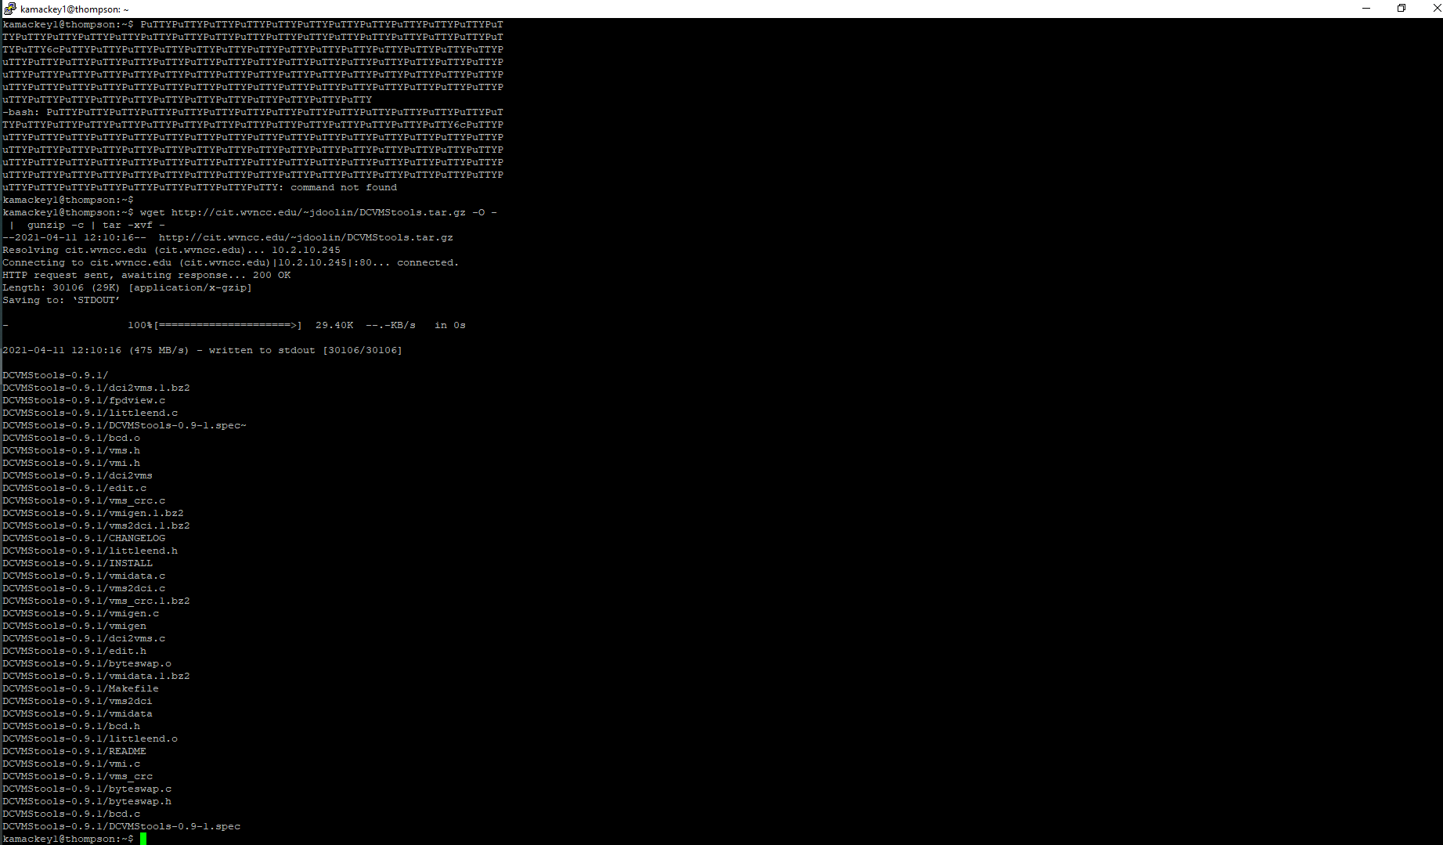

* Slick, ain't it?

7) Change to the directory that was created.

8) Enter the following command:

* grep jdoolin *
* grep jdoolin *.c
* grep jdoolin * | grep -v printf
* **Take a screenshot and describe what these commands did.**

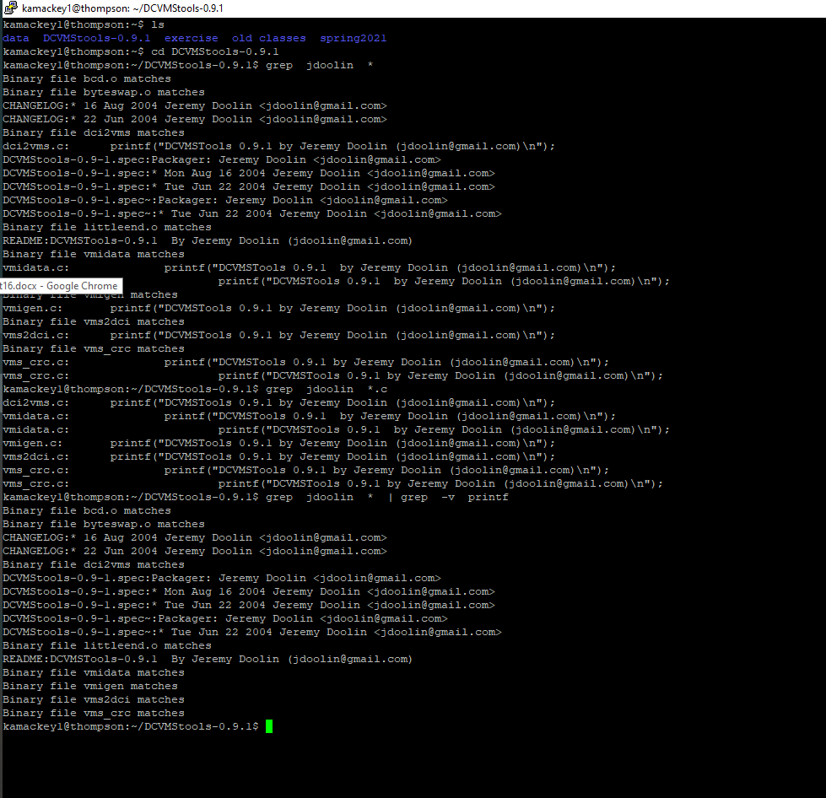

The first pulled all the files that had any ties to JDoolin, the secondand displayed all files that had Jdoolin attached to it ending with a .c and the last pulls all files with Jdoolin attached to it but excluding those that contail printf

9) Enter the following commands:

* dd if=/tmp/sda of=mbr.bin count=512
* file mbr.bin
* **Take a screenshot. Describe what this command did.**

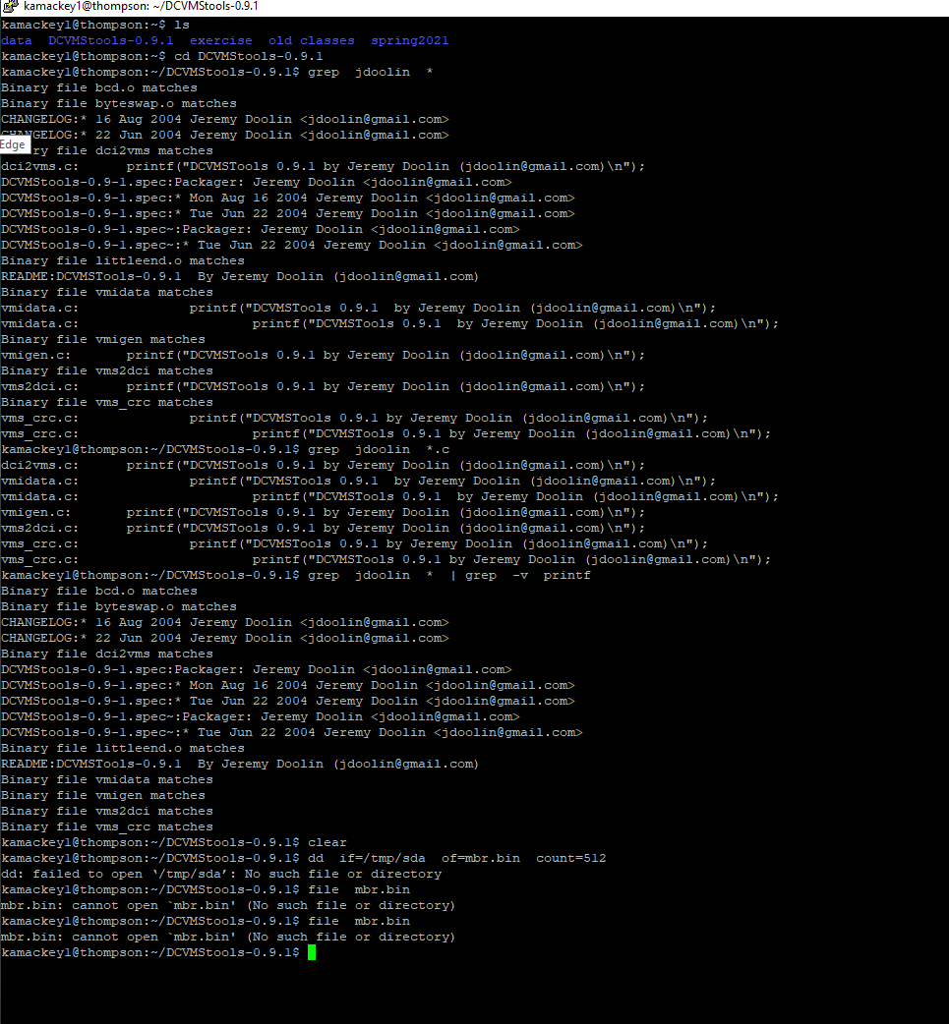

**The first one made a backup and pulled back everything I had cleared and made a backup. The second one told me no such file or directory existed so im not sure if I did something wrong there.**

10) Relax for a minute

11) cd back to your home directory

* zip -r DCVMStools.zip DCVMStools-0.9.1/
* tar -cvf DCVMStools.tar DCVMStools-0.9.1/
* bzip2 DCVMStools.tar
* ls
* bunzip2 DCVMStools.tar.bz2
* ls
* gzip DCVMStools.tar
* gunzip DCVMStools.tar.gz
* ls
* tar -xvf DCVMStools.tar
* ls
* rar a DCVMStools.rar DCVMStools-0.9.1/
* ls
* unrar x DCVMStools.rar
* file DCVMStools.zip DCVMStools.tar.bz2 DCVMStools.tar.gz DCVMStools.rar
* **Take a screenshot.**

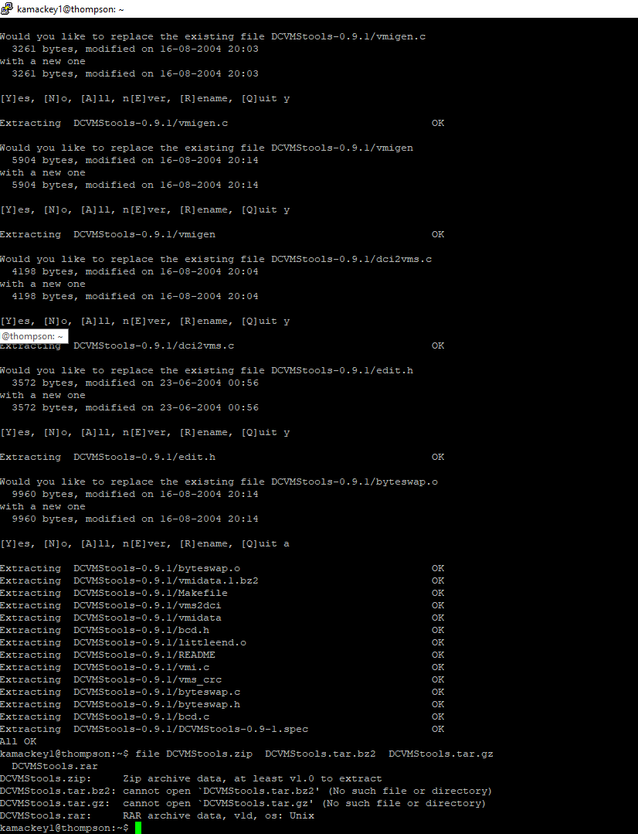

2 point per screenshot (12 points)

2 points per description of the first five screenshots (10 points)